**2.7.1 Student Satisfaction Survey (SSS) on Teaching Learning Process 2018- 2019**

Late B R D Arts & Commerce Mahila Mahavidyalaya, Nashik Road

Please answer the following questions for online student satisfaction survey regarding teaching learning process. (Grade 0- 4)

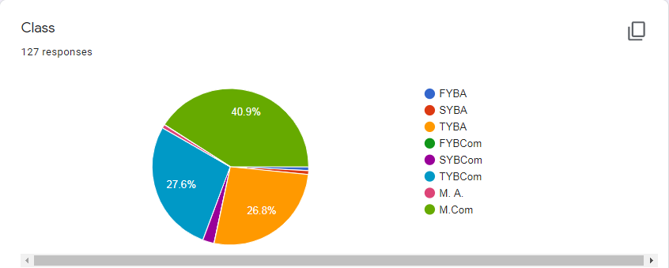

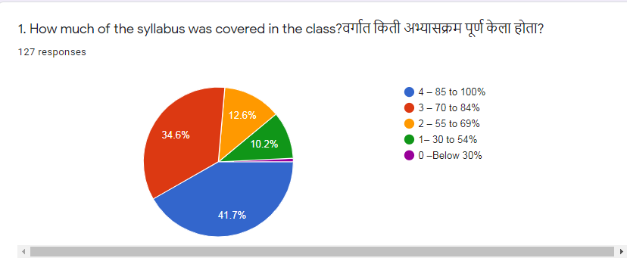

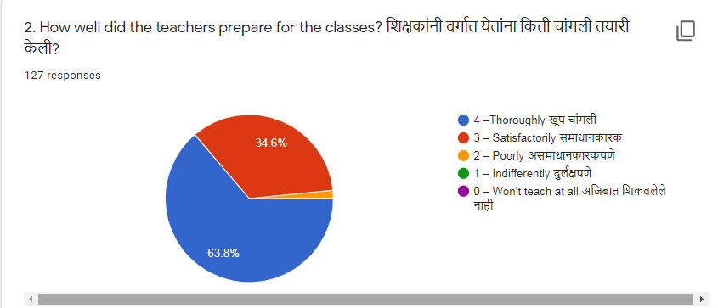

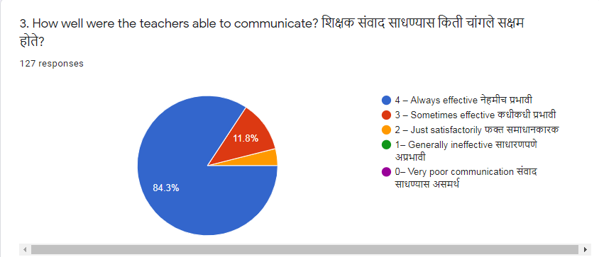

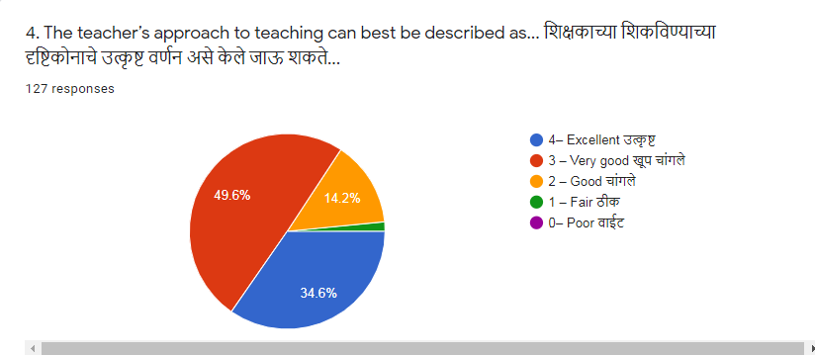

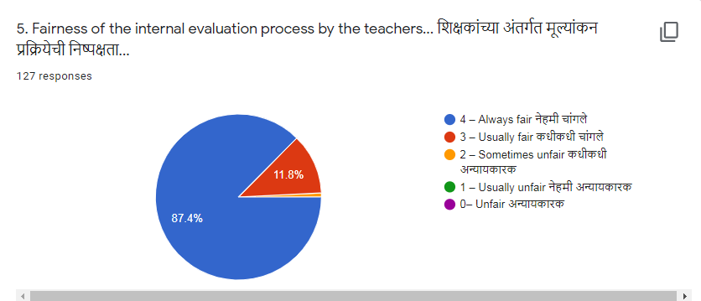

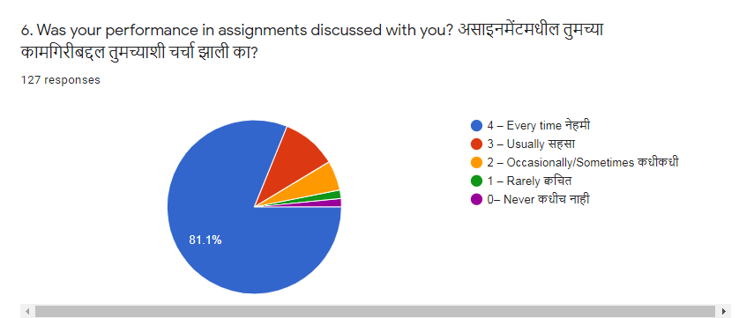

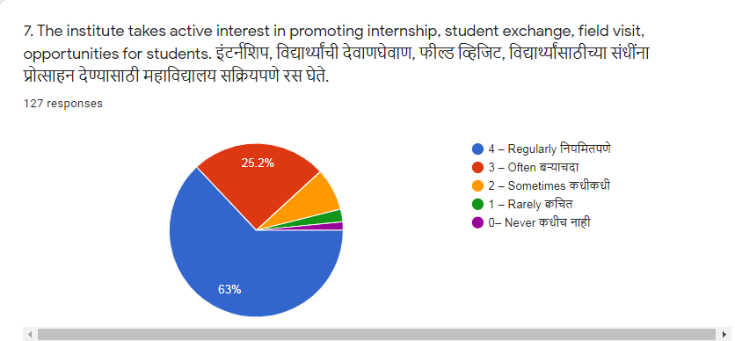

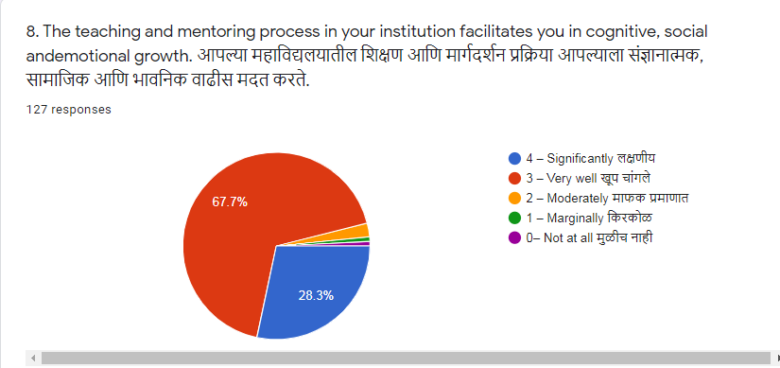

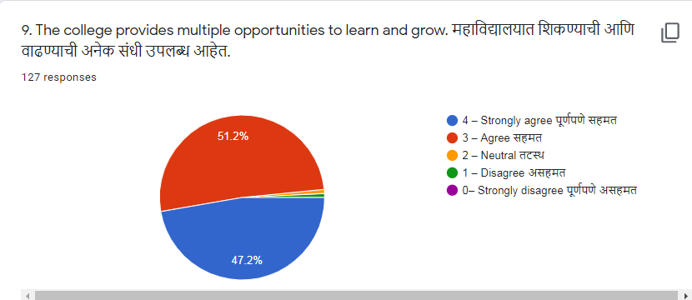

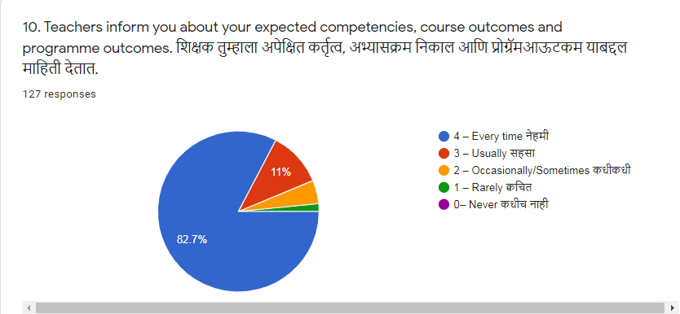

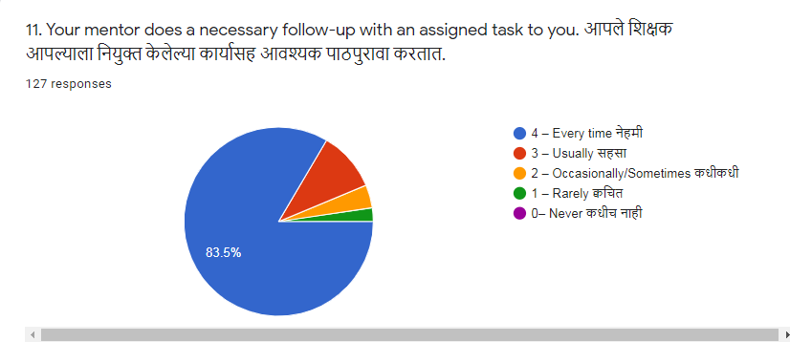

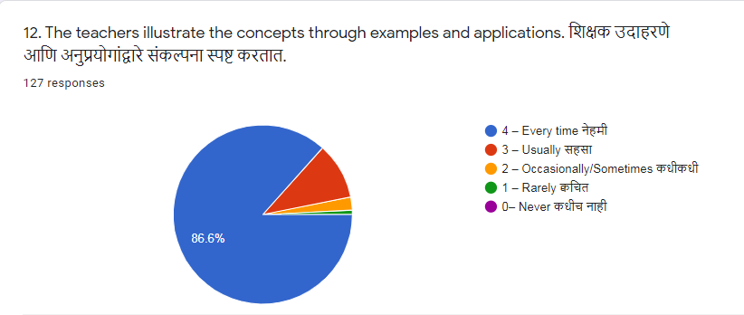

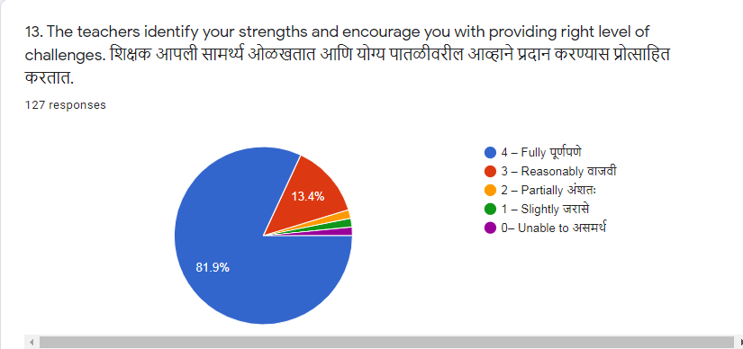

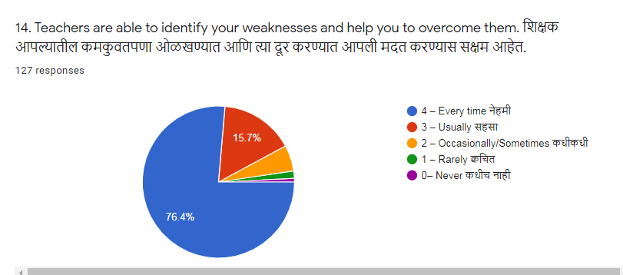

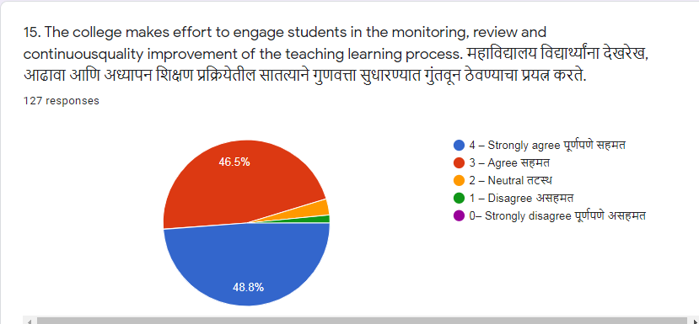

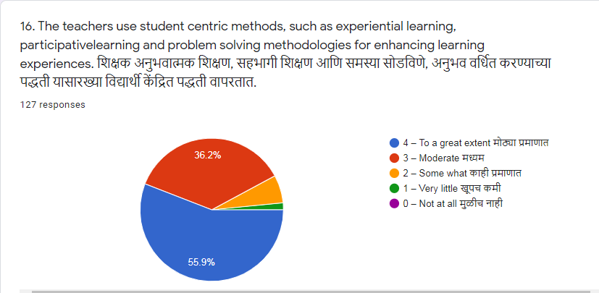

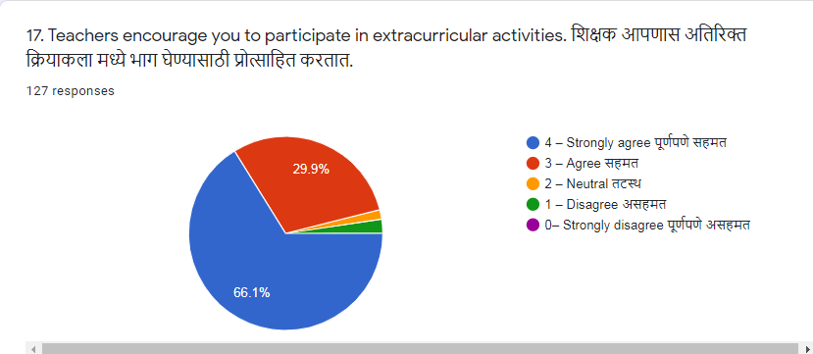

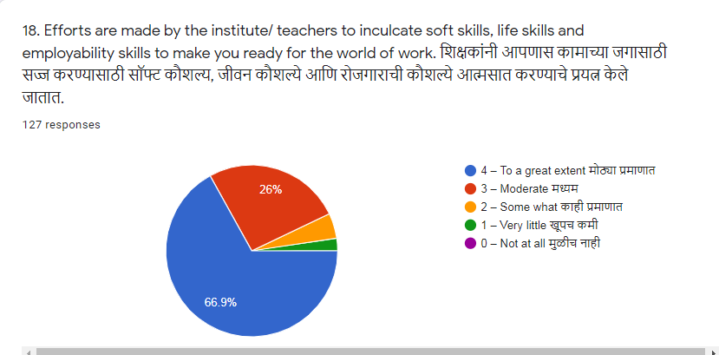

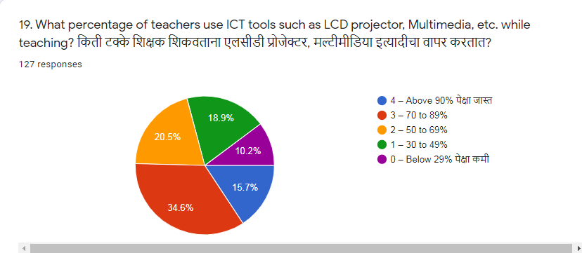

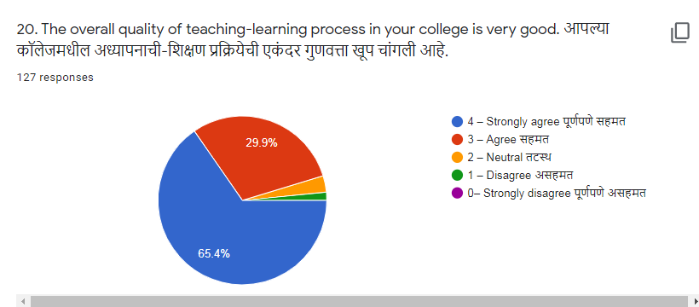

Suggestions, if any... सूचना, काही असल्यास ...

40 responses

No

Nothing

Nothing

🙏

_

Good clg ad good all staff

Communicate students in every aspects

In Mcom 2nd semester project work teacher not suggest subject of project work due to irregular presenty reason. But me belong poor background family so I can join part time job yet they not listen. I suggest help to our students they can trie to learn education.

Good learning experience

Increase books in library

-no

Never

Nating

No

Shikshakanni vidhyardhyanna purn pane protsahit krne

No any suggestions.

TO enhance the opportunities for job oriented skills & placements .giving the experience of internship training .

No suggestions

NO

Noo

No

Projecter pahije shikvnyasathi

No. Allready all perfect..

No suggestions

No chenege